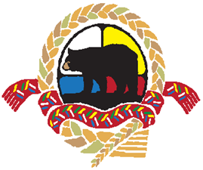

Aboriginal Health High School Internship Program (AHHSIP)
is seeking interested Aboriginal students.

Southern Health-Santé Sud is seeking Aboriginal High School students interested in opportunities within healthcare. Students can expect to experience a wide range of health care careers available in the Southern Health-Santé Sud region through mentorship by health services staff. Interns will be of Aboriginal decent (First Nation, Métis or Inuit) & students returning to high school or post-secondary in the fall.
The Internship is split into two phases

PHASE ONE - VOLUNTEER &
JOB SHAWDOW TERM
Start date: February-June (4months)
- Collaborations between the student, school, and Southern Health - Santé Sud will determine the student’s work schedule.
- One 6 hour day, bi-weekly
- Some high schools may also provide students with a ½ credit for the 55 hours of volunteer time accumulated in Phase 1

PHASE TWO - SUMMER EMPLOYMENT TERM
Start Date: July-August (6 weeks paid employment approximately $12.00/per hour)
- Interns must have successfully completed phase one to qualify
- Summer employment term positions are available in various departments

This is a wonderful opportunity for Aboriginal high school students to explore and render various careers available in healthcare, experience diverse job placements, gain volunteer experience for resumes, learn new computer skills, organizational skills and communication skills, comprehend and provide service to others, and a chance to earn money.

To participate, follow these steps:

Step 1 Fill out an AHHSIP application.
Step 2 Attach resume if available.
Step 3 Fax or email application and resume to corresponding contact information below, or submit to your high school contact who can submit it for you.

For more information, please contact:
Kayla Tanner, Administrative Assistant – Recruitment & Indigenous Employment
Phone: (204) 428-2724
Fax: (204) 428-2782
E-mail: ktanner@southernhealth.ca

